AI Assisted Coding – 16.3

Veerla Sathvika
2303A5243
Batch:38
Task 1: (Design Database Schema for Student Management System)

Prompt:
Design a relational database schema for a Student Management System using SQL. Create tables for Students, Courses, and Enrollments with proper primary keys, foreign keys, and normalized structure.

Code:
Create Students Table
CREATE TABLE Students ( student_id INT PRIMARY KEY, name VARCHAR(100),
email VARCHAR(100)
);

Create Courses Table
CREATE TABLE Courses ( course_id INT PRIMARY KEY, course_name VARCHAR(100), credits INT
);

Create Enrollments Table (IMPORTANT ForeignKey)

CREATE TABLE Enrollments ( enrollment_id INT PRIMARY KEY, student_id INT,
course_id INT,
FOREIGN KEY (student_id) REFERENCES Students(student_id), FOREIGN KEY (course_id) REFERENCES Courses(course_id)
);

Sample Input/Output:
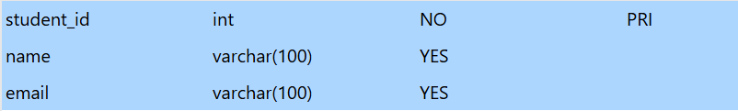
Create Students Table

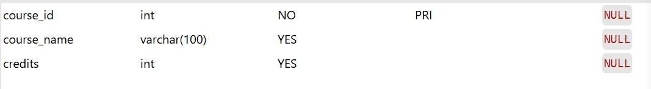
Create Courses Table

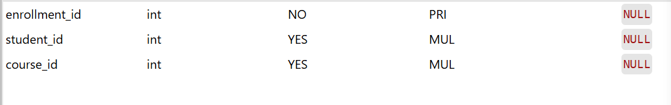
Create Enrollments Table (IMPORTANT ForeignKey)

Explanation:
- This task focuses on designing a normalized relational database schema.
- The Students table stores student personal details.
- The Courses table maintains course information and credit values.
- The Enrollments table establishes a many-to-many relationship between students and courses.
- Primary keys uniquely identify each record in the tables.
- Foreign keys enforce data integrity between related tables.

- The schema follows normalization principles to reduce redundancy.
- This structure supports efficient data retrieval and management operations.

Task 2: (Insert Sample Records)

Prompt:
Insert sample records into Students, Courses, and Enrollments tables using SQL queries. Display the inserted data to verify successful database population.

Code:
Insert into Students
INSERT INTO Students VALUES
(1, 'Rahul', 'rahul@gmail.com'),
(2, 'Sneha', 'sneha@gmail.com'),
(3, 'Arjun', 'arjun@gmail.com');

Insert into Courses
INSERT INTO Courses VALUES (101, 'DBMS', 4),
(102, 'Python', 3),
(103, 'AI', 5);

Insert into Enrollments
INSERT INTO Enrollments VALUES (1, 1, 101),
(2, 2, 102),
(3, 3, 103);

Sample Input/Output:
Insert into Students

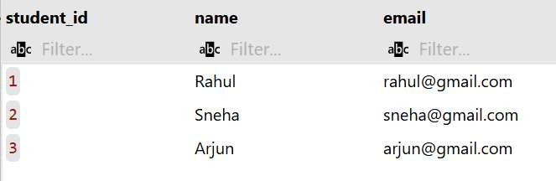
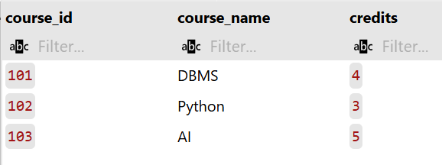
Insert into Courses

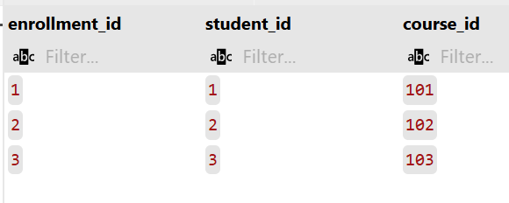
Insert into Courses

Explanation:
- This task demonstrates how to populate relational tables with sample data.
- INSERT statements are used to add student, course, and enrollment records.
- The Enrollments table references valid student and course IDs ensuring referential integrity.
- Proper ordering of insert operations prevents foreign key constraint errors.
- SELECT queries help verify that the records are stored correctly.
- Displaying table contents confirms successful database transactions.
- This step is essential before performing query operations like joins or updates.
- The populated database now supports real-time academic data management

operations.

Task 3: (Perform CRUD Operations)

Prompt:
Write SQL queries to retrieve student details along with their enrolled course information using JOIN operations. Display filtered results based on specific conditions such as course name or credits.

Code:
Update Student Email
UPDATE Students
SET email = 'rahul_new@gmail.com' WHERE student_id = 1;

Delete Enrollment Record DELETE FROM Enrollments WHERE enrollment_id = 3;

Sample Input/Output:
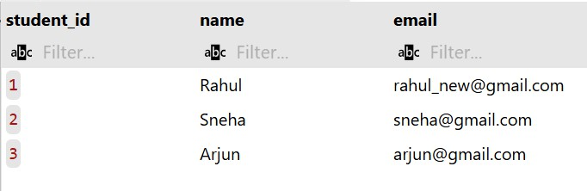
Update Student Email

Delete Enrollment Record

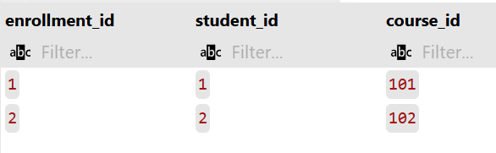

Explanation:
- This task demonstrates execution of fundamental CRUD database operations.
- SELECT query is used to retrieve course information from the Courses table.
- UPDATE query modifies an existing student email ensuring accurate data maintenance.
- DELETE query removes an unwanted enrollment record from the database.
- WHERE clause is used to target specific rows during update and delete operations.
- Validation using SELECT statements confirms successful modification of records.
- These operations are essential for real-time database management systems.
- Proper CRUD handling ensures data consistency and integrity in relational databases.

Task 4: (Execute Aggregate Queries)

Prompt:
Write SQL queries using aggregate functions to analyze course and enrollment data. Calculate total number of students enrolled and average course credits.

Code:
Count Number of Students Enrolled Per Course
SELECT
c.course_name,
COUNT(e.student_id) AS student_count FROM
Courses c JOIN
Enrollments e ON c.course_id = e.course_id GROUP BY
c.course_name;

Display Courses with More Than One Student
SELECT
c.course_name,
COUNT(e.student_id) AS student_count FROM
Courses c JOIN
Enrollments e ON c.course_id = e.course_id GROUP BY
c.course_name HAVING
COUNT(e.student_id) > 1;

Sample Input/Output:

Count Number of Students Enrolled Per Course

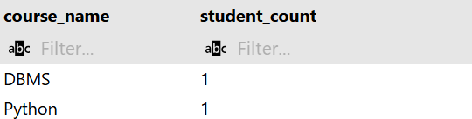


Display Courses with More Than One Student

Explanation:

Analysis of Correctness
- The Join: Using JOIN (Internal Join) ensures that only courses with at least one enrollment are counted. If you wanted to see courses with zero students, you would use a LEFT JOIN.
- The Grouping: Grouping by c.course_name is effective, though in a production environment, grouping by c.course_id is safer to avoid merging two different courses that happen to have the same name.
- The Filter: The HAVING clause correctly targets the aggregate COUNT, ensuring the output only lists courses that meet the ‘more than one’ criteria.

Task 5: (Query Optimization)

Prompt:

Create a SQL VIEW to display student names along with their enrolled course names. Use the view to retrieve simplified academic information from multiple related tables.

Code:
The Original Query (Subquery)
SELECT * FROM Students WHERE student_id IN (
SELECT student_id FROM Enrollments WHERE course_id = 101
);

The Optimized Query (JOIN)
SELECT s.*
FROM Students s
JOIN Enrollments e ON s.student_id = e.student_id WHERE e.course_id = 101;

Sample Input/Output:
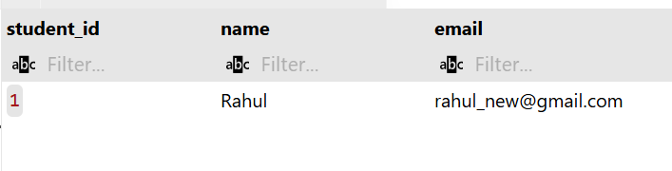

Explanation:
Analysis of Correctness & Performance Correctness

- Identical Results: Both queries will return the exact same rows from the Students table specifically, those students who have a record in the Enrollments table for course_id = 101.
- Duplicate Handling: Note that if a student is enrolled in the same course multiple times (which shouldn't happen with proper constraints), the JOIN might return duplicate rows, whereas the IN subquery would not. To ensure 100% parity in all scenarios, you could add SELECT DISTINCT s.*.
Why the JOIN is "Optimized"
- Execution Plan: Modern SQL optimizers are very good at handling JOIN operations. They can use "Nested Loop Joins" or "Hash Joins" to find matches much faster than evaluating a list of IDs.
- Indexing: A JOIN makes it very easy for the engine to utilize an index on Enrollments.student_id and Students.student_id.
- Readability: As queries grow more complex (e.g., needing data from 3 or 4 tables), JOIN syntax remains much cleaner and easier to maintain than nested layers of subqueries.

